WEST FARM SURGERY

31 West Farm Surgery, West Farm Avenue, Longbenton,
Newcastle upon Tyne, NE12 8LS.
TEL: 0191 2662215
nencicb-nt.westfarmsurgeryreception@nhs.net
www.westfarmsurgery.nhs.net
Dr Joanne Lee - Dr Kate Grisaffi - Dr Clair Wooldridge - Christine Davidson – Managing Partner
Dr McInnes Salaried GP - Dr Roshida Khan - Salaried GP

Dear Patient,

Welcome to West Farm Surgery. Please read this document fully before completing your
registration documents.

- You MUST complete all sections of this form to the best of your knowledge. This is to ensure we are able to provide you with appropriate care.
- You can book appointments, order prescriptions or view your medical records through the patient access system. If you wish to be registered for online access please let us know on your registration form.
- We offer an electronic prescription service. This means you can have your medication sent directly to a pharmacy of your choice. If you would like to use this service please complete the required section of the form. (Section two)
- If you are taking any medications it is important that you list them all. Please complete the required section of the form. (Section two)
- We are required to provide you with a named GP. This will not affect your care as you are able to see any GP within the surgery. You will be informed of your named GP when handing in your registration form. If you need to check this information at any time in the future please ask at reception.
- If you require an interpreter for your appointment please let us know as soon as possible, specifying the dialect wherever possible.
- If you are a veteran please ensure you have provided the surgery with your in-service medical summary (this is to ensure we are able to provide the best care)
- If you are registering a child please provide identification for yourself and your child.
- More information about West Farm Surgery can be obtained by looking on our practice website www.westfarmsurgery.nhs.uk or by asking for a copy of our practice information leaflet.
- Attached to this pack is some information regarding your personal data and how it is used by the NHS, please read this document carefully.

The reception team are here to help you, if you wish to clarify any information please ask.

Yours Sincerely,
The Team at West Farm Surgery

NEW PATIENT QUESTIONNAIRE

Please complete all sections of this form and return with you GMS1 for and required ID.
- Please complete this form in BLOCK CAPITALS.
- Please make sure you have photo ID and proof of address when you are registering.
- If you are newly arrived in this country, please bring your passport to confirm your date of birth and entitlement to NHS treatment.
- If you require any assistance completing this form, please ask.

SECTION ONE
Title | Mr / Mrs / Miss / Ms / Dr / Rev / Other | Date of birth | / / |  | Are you | Male / Female
Surname |  | Forename |  |  | Middle name
Known as |  | NHS Number |  |  | Religion
Marital status |  |  | Occupation
Address:  Postcode: |  |  | Landline:  Mobile:  Work Number:  Email:
Ethnicity – Please circle your answer.
White British British / Mixed White / Asian Other Asian
Irish Other White Caribbean Indian / British African W&B Caribbean Other mixed British/ Pakistan Other Black British / Bangladeshi W&B African Chinese Do not wish to disclose
Country of birth: |  |  | Do you require an interpreter YES / NO  If yes, Do you require a specific dialect?  Would you prefer your interpreter to be  MALE / FEMALE / EITHER
Main spoken Language?

What is your preferred method of contact? (Please select ONE option, if none selected will default to call to mobile number)

No preference Call to home Call to work Call to mobile Letter to home
Do you consent to receive text notifications for clinical services: YES / NO

This includes appointment reminders and messages to patients identified as having a long term health condition, e.g. patients identified as eligible for flu vaccinations.
Do you wish to be registered for patient online access? YES / NO
Please ensure you have provided your email address, your access pin will be sent to this address once authorised.

There two types of access that we can provide. Please see below for details:
Basic Access  Gives you access to book and cancel appointments (is available) and order REPEAT prescriptions. |  |  |  | Advanced Access  Gives you access to some of your medical record from the date of your application, this must be authorised by a GP.
If you wish to be registered for online access please speak to a receptionist and ask for the online access application form. Please note it may take up to 28 days for your access to be granted. This is based on the type of access you would like and staffing levels to process the requests.
Do you consent to sharing your data on the Summary Care Record (SCR)
The SCR is an electronic summary of key clinical information (including medicines, allergies and adverse reactions) about a patient and would be available to be viewed by all NHS services such as hospitals and walk-in centres t to support your care and treatment. This information is only used by NHS organisations and will not be shared without prior consent.
Please tick ONE option below

Express consent for medications, allergies and adverse reactions only.

Express consent for medications, allergies, adverse reactions and additional information.

Express dissent (opt out) – This means you would not have a summary care record.

Communication Needs
We want to make sure that we communicate with you in a way this is easy for you and that you understand.
- We want to know if you information in a specific form e.g. braille, large print or easy read.
- We want to know if you need to receive information in a particular way e.g. electronically, via email or for use with a screen reader.
- We want to know if you need someone to support you at your appointment e.g. a sign language interpreter or an advocate.
- We want to know if you lip-read or use a hearing aid or communication tool.

Do you have any communication needs? YES / NO

If so how can we address these needs when communicating with you?

Are you a carer? YES / NO

i.e. do you look after someone on a daily, long-term basis and you are not paid?
Is this person registered with this surgery YES / NO
Name of the person you care for:
Are you a veteran? YES / NO

When did you leave active duty?
Please ensure you have provided your medical summary from you in-service care.

NEXT OF KIN
Name: |  |  | Is this person registered with West Farm Surgery?  YES / NO
Contact Number: |  |  | Address:
Relationship to you:

Do you give West Farm Surgery permission to discuss your care with this person? YES / NO

PLEASE NOTE: By selecting yes, you are giving the surgery permission to discuss your FULL medical record including: consultation information, appointment details, test results, referrals and any messages form the GP
- IF YOU HAVE SELECTED YES, PLEASE ENSURE THE ‘CONSENT TO DISCLOSE CONFIDENTIAL INFORMATION’ FORM HAS BEEN COMPLETED AT THE BACK OF THIS PACK. IF THIS IS NOT COMPLETED WE CAN NOT SHARE ANY INFORMATION!
- PLEASE NOTE – THE PERSON LISTED ABOVE MUST MATCH THE PERSON LISTED ON THE ‘CONSENT TO DISCLOSE CONFIDENTIAL INFORMATION’ FORM.

SECTION TWO – MEDICAL HISTORY
Please detail any special needs you may have (e.g. disability etc.)

Medical History
Please detail any serious illnesses / operations / accidents and the year they took place

Medication
Please list any medication you take on a regular basis

We use the electronic prescription service at this practice. If you would like to nominate a pharmacy to send you prescriptions to please provide details below.

Name of Pharmacy:

Address of pharmacy:

Can you let us know if any of your relatives have had any of the following and how old they were when it happened:

Angina or Heart Attack YES / NO Relationship:__________________ Age:___________

Stroke YES / NO Relationship:__________________ Age:___________

High blood pressure YES / NO Relationship:__________________ Age:___________

Diabetes YES / NO Relationship:__________________ Age:___________

Asthma YES / NO Relationship:__________________ Age:___________

Do you smoke? YES / EX-SMOKER / HAVE NEVER SMOKED

If yes, would you like advice about giving up? YES / NO

If yes, do you smoke: CIGARETTES / ROLLING TOBACCO / PIPES / CIGAR

If yes, how many cigarettes, cigars, pipes do smoke per day? ______________________

If you are an ex-smoker, when did you give up? ______________________

Health Status | Height:
 | Weight:
Women Only | Date of last smear:
 | Result:

SECTION THREE – ALCOHOL SCREENING TEST
How often do you have eight or more drinks on one occasion? | Never Less than monthly Monthly  Weekly Daily/Almost Daily
How often during the last year have you been unable to remember what happened the night before because you had been drinking? | Never Less than monthly Monthly  Weekly Daily/Almost Daily
How often during the last year have you failed to what was normally expected of you because you had been drinking? | Never Less than monthly Monthly  Weekly Daily/Almost Daily
Has a relative of friend, a doctor or any other health worker been concerned about your drinking or suggested you cut down? | No Yes, but not in the last year  Yes, in the last year
SECTION FOUR
Have you recently entered the UK  YES / NO | Date entered UK:
 | How long have you been given permission to stay?
Passport/ Visa verified by:
(office use only)

Are you a UK National living abroad?  YES / NO  If yes do you have any of the following:  E112 / E119 / E128 | Verified by:  (office use only)
If you are not from the UK do you have a valid European Health Insurance Card? | verified by:  (office use only)
Have you provided 2 forms of acceptable ID? | ID Provided:
PATIENT DECLARATION
I can confirm that the information held on this form is correct to the best of my knowledge. |  | Date
 |  | Signature
FOR OFFICE USE ONLY
PROOF OF ID PROVIDED: | NEW PATIENT CHECK APPOINTMENT:
STAFF MEMBER VERIFYING: | GP APPOINTMENT (MEDICATION REVIEW):

CONSENT TO DISCLOSE CONFIDENTIAL MEDICAL INFORMATION
West Farm Surgery

Section One – Patient details
Name: |  | Date of birth:
Address:

I hereby consent to the disclosure of my private medical information to:
Section Two – Next of kin details
Name: |  | Date of birth:
Relationship: |  | Contact number(s):
Address:

Please tick the statement/s applicable:
You must select ONE of the options below. If no selection we cannot share any information

Full and open ended disclosure of any matter related to my medical record

Full disclosure of any matter related to my medical record for the period
(FROM)_____________________________ (TO)______________________________

Limited disclosure of the following aspects of my medical record:

Test Results Appointment Queries

Prescription queries Referral Queries

Any other matter related to my medical record. Please state below:
_______________________________________________________________

I am aware that this consent may be revoked by me at any time, in writing to the Practice Manager.
Patient Signature: ______________________________________ Date: ________________

This page is intentionally blank. Please do not record any information on this page
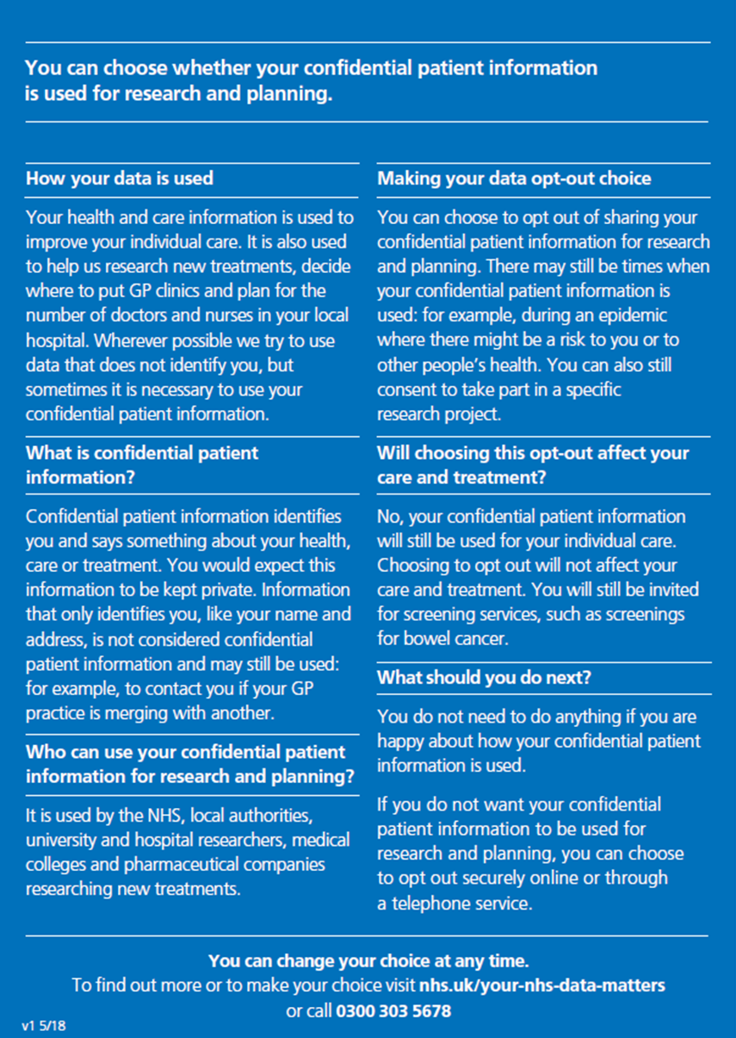
For office use only – Witnessed by
Name: |  | Designation:
Signature: |  | Date:

